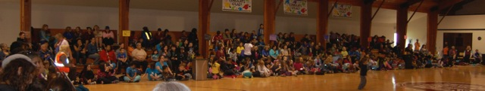

**Enhancement Agreement Annual Report 2014**

**School District 50 Haida Gwaii**

**1. Preamble**

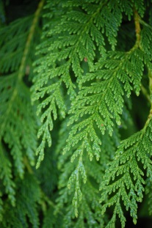The purpose of an Aboriginal Education Enhancement Agreement is to enhance the educational success of Aboriginal students. School District 50’s Enhancement Agreement (‘EA’) was first signed in 2012; this is our first submitted annual report, and as such offers a ‘baseline’ for future decisions by the EA group.

It is the belief of all the partners to this agreement that enhancing the achievement of Aboriginal students requires changes that will benefit all students in the district. It is our vision that we must prepare the next generations to adapt to, live in, and flourish in a rapidly changing world, of which our students must be an integral part. Our commitment is to make changes so that these benefits can be enjoyed by Aboriginal and non-Aboriginal students alike. This Enhancement Agreement acknowledges and honours the Haida Nation as the First People of these islands.

**2. Partnerships**

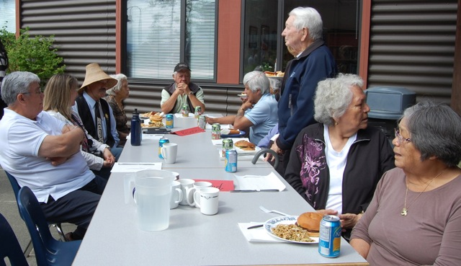Collaborative decision making occurs with our communities and stakeholders on all issues of importance, including the development of this document. The partners to this agreement include School District No. 50 (Haida Gwaii), the Old Massett Village Council, the Skidegate Band Council, the Council of the Haida Nation, and the Ministry of Education. Many other partners have been involved in making this Agreement a reality: Literacy Haida Gwaii, which leads a variety of community literacy initiatives; Community Futures, which plays a key role in on-island adult education and career development; Swan Bay and Lepas Bay Rediscovery, along with Mount Moresby Adventure Camp, which offer on-the-land educational opportunities for young people; the various PACs and DPAC throughout the School District; and the University of British Columbia, which has been involved in long-term research partnerships with Haida Gwaii communities.

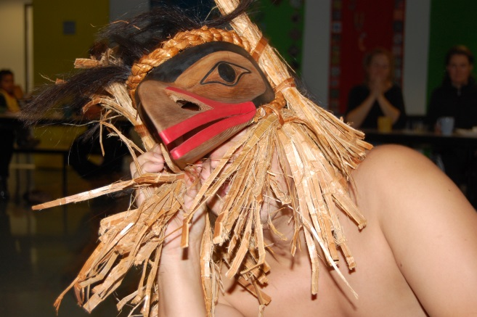

Consultation has occurred on the EA since 2003. Collaborative meetings have occurred in Old Massett, Masset, Skidegate, and Queen Charlotte. They have involved the parties noted above as well as parents, elders, and community members at large. They have been hosted in a variety of formats, but most commonly as a general discussion to generate ideas and opinions on the development of the EA.

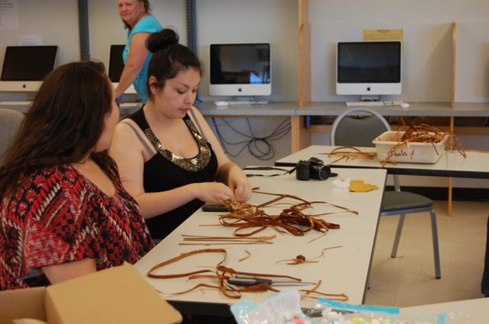Many community members expressed a desire to see students learning more about the language, places where they live, Haida history and culture, and economic and ecological issues that will shape the future of the islands’ communities. Progress in this area was seen as important for its own sake, as well as a potential means of increasing students’ engagement with school and hence academic success and graduation rates. On the part of school staff, the view was widely shared that many resources available on the islands are not used adequately in the schools. Staff new to the district indicated that it was not easy to familiarise themselves with the range of materials, people, and places that might be relevant to their teaching. Experienced staff recalled times when the district placed a greater emphasis on outdoor education, the integration of Haida content, or in-classroom demonstrations of new resources. There was a shared belief that too much depends at present on the initiative of individual staff. This has led to an emphasis on ‘Culturally Responsive Education’ intertwining Science, Math, Social Studies and Language Arts with the language, history, culture, and ecology of Haida Gwaii, in an effort to embrace and embed Haida culture in our actions and instruction, so as to not perpetuate the assimilative model that informed educational practise back to the days of residential schools.

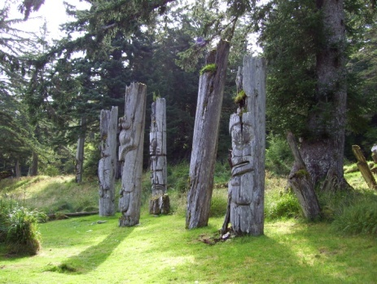

**3. Principles**

The goal areas selected for enhancement are those where there is assurance that:

* Data can be tracked with integrity and can be effectively used to implement intervention.
* Goals are related to School District No. 50’s Achievement Contract, which is focused on the success of aboriginal students. The AC can be retrieved at <http://sd50.bc.ca/district/accountability-cycle/achievement-contract-2011-2012-4/>
* The Enhancement Agreement will be reviewed annually by the Haida Education Council. Changes in goals, as with other endeavours, will be through consultation and mutual agreement.
* School plans and Achievement Contracts are developed in accordance with the Enhancement Agreement.
* Old Masset Village Council, Skidegate Band Council and the Council of the Haida Nation will ensure that their own educational initiatives are planned to complement and strengthen the measures outlined in the Agreement.

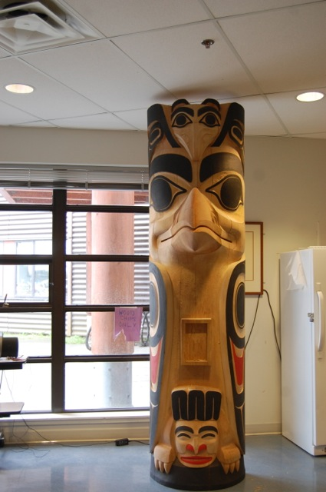

**4. Goal Areas**

For each goal area, a brief summary is provided.

**Goal Area 1**

**That students develop a strong sense of belonging to their learning environment and community.**

We strongly believe that our students know who they are and where they come from, but we continue to improve our capacity in reinforcing this. We are also seeking to improve support and intervention for students experiencing difficulties, whether personal or academic.

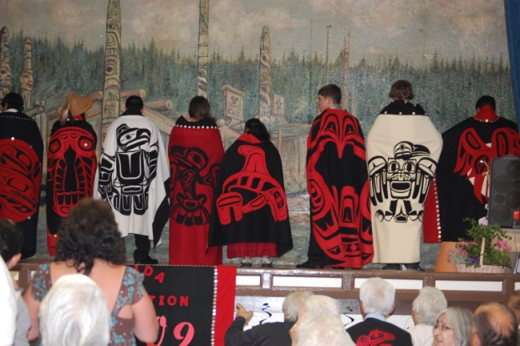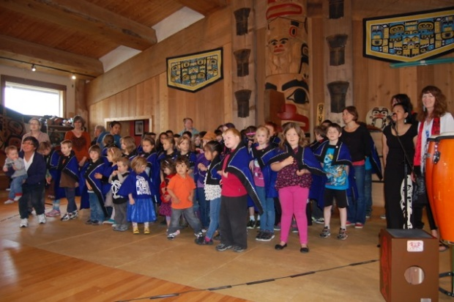

This was an area of great concern for both community members and district staff. Students describe their favourite teachers as those that “get it”. Those most engaged at school have broad support from family, community and staff to succeed. Community members were concerned that the students in greatest need of academic support were often placed with learning assistants or teaching assistants who lacked the specialized knowledge needed to help them. Staff expressed a desire for lower student-teacher ratios and for more professional counselling for students. We recognise that aboriginal learners of other Nations will also be supported.

Indicators of Success:

* Survey/interview of Secondary Students on their school connectedness;
* Early Leaver’s Data;



“*After a few years, I realised they were teaching me more than I was teaching them.”*

Teacher, QCSS



* Improved School Attendance.

Commitments:

* We believe that our students will benefit from a strong connection to their school and that teachers will benefit from an increased awareness of Haida traditional knowledge and language, utilising strategies ranging from Culturally Responsive Education to aboriginally oriented Early Childhood Education programming.
* We will ensure on-going cultural enrichment not only for our students but our staff as a whole.

*Commentary on Baseline data for Goal Area 1: Our evidence indicates that the vast majority of our students feel a connection to their school and community, and this is positive news. However, as long as one student feels disconnected or unsafe at school, there is work to do in this regard. Further, it is interesting to note the surprisingly low result for ‘are you learning about First Nations at school’? We have posited that it is possible that it is so pervasive in our schools that students only notice when it is non-Haida information. Review of this result will be conducted in the coming year.*

**Goal Area 2**

**Improve grade transition rates and school completion rates, with enhanced academic performance in key meaningful high school subjects (English, math, science, social studies).**

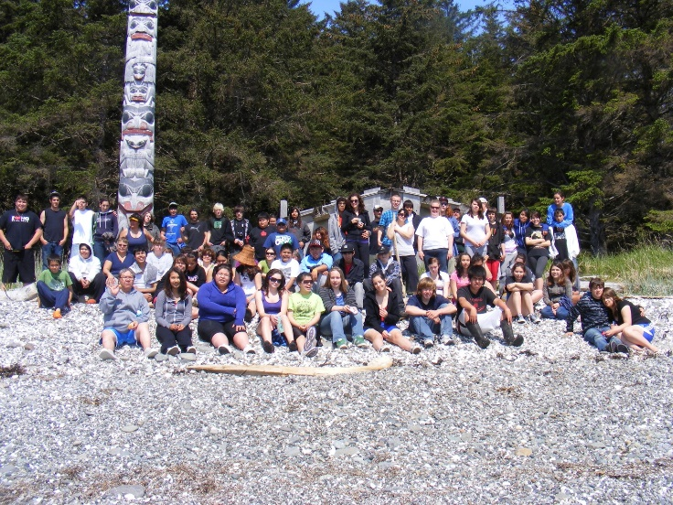This was affirmed as a key goal area in the engaged consultation process. Community members are aware that many Aboriginal youth fail to complete high school. This goal is the basis our District’s Achievement Contract, and District staff shares this goal and are aware of the complex challenges involved in raising graduation rates and academic performance. Progress in Goal Area 2 is therefore likely to come about as a result of many separate initiatives, not all of which involve the high schools directly. For example, in October 2010 the Haida Child and Family Services hosted a symposium at which the youth of Haida Gwaii signed a Haida Nation Children and Youth Declaration outlining their rights and responsibilities. An on-going conversation will be held with HEC and other partners as defining what success looks like for aboriginal students, and to continue to explore what barriers our students face.

Indicators of Success in Goal Area 2:

* Improving Six-year completion rates, and specifically Dogwood graduation;
* Successful Grade-to-grade transition rates;
* Required Provincial exam scores and participation in Grades 10, 11 and 12;
* Improving Foundations Skills Assessment, Vancouver Island Math Assessment and Writing Sample results; and
* Tracking of Post-Secondary Success.

Commitments:

* To giving our students and families the information, courses and learning experiences they need to be successful on their learning journey.

*Commentary on Baseline data for Goal Area 2: Results in Six year completion continue to show a positive trend, with SD 50 above the provincial average for aboriginal students. However, evidence shows that recently aboriginal males have had a notable decline in completion. We will be watching to see if this is a one-time issue or a trend. An area of concern has been the Grade 9 transition, which was extremely low in 2013, but has increased for the 2014 year. Again, we will see if this is a one-time issue. A final note is to observe that our aboriginal and non-aboriginal academic results are very closely tied together.*

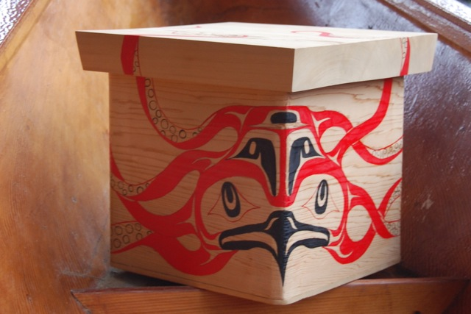School District 50 Haida Gwaii

Enhancement Agreement Appendix:

Evidence 2013

**Goal Area 1**

That students develop a strong sense of belonging to their learning environment and community.

|  |  |  |  |  |
| --- | --- | --- | --- | --- |
| Are you being taught about Aboriginal People in Canada? | | | | |
|  | Gr 3&4 | Gr 7 | Gr 10 | Gr 12 |
| 2009/10 | 61 | 48 | 50 | 25 |
| 2010/11 | 43 | 43 | 65 | 27 |
| 2011/12 | 56 | 40 | 37 | 60 |
| 2012/13 | 18 | 50 | 63 | 45 |
| 2013/14 | 44 | 38 | 61 | 29 |

|  |  |  |  |  |
| --- | --- | --- | --- | --- |
| How many adults at your school care about you? (percentage responding 2 adults or more) | | | | |
|  | Grade 3&4 | Grade 7 | Grade 10 | Grade 12 |
| 2009/10 | 93 | 88 | 83 | 100 |
| 2010/11 | 100 | 75 | 85 | 77 |
| 2011/12 | 90 | 80 | 86 | 33 |
| 2012/13 | 93 | 86 | 66 | 94 |
| 2013/14 | 92 | 88 | 65 | 94 |

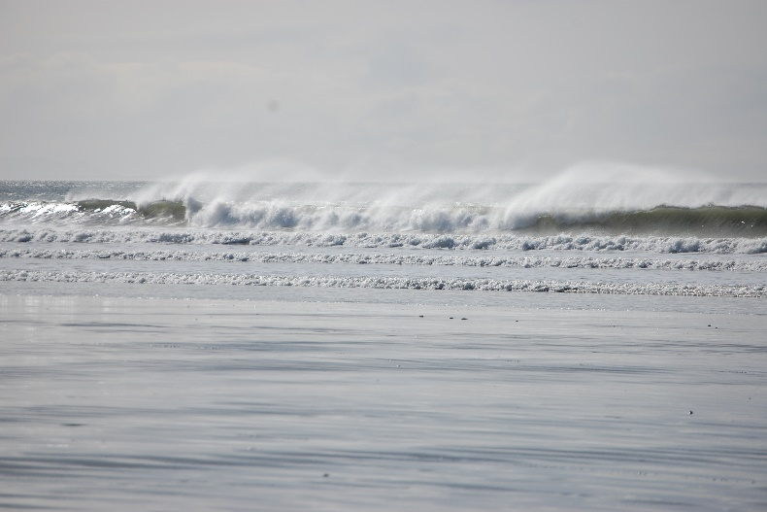

**2012-2014 Overview of Major Activities reflective of Goal Area** 1

*That students develop a strong sense of belonging to their learning environment and community.*

|  |  |
| --- | --- |
| 2012-13 | 2013-14 |
| Canoe Journey @QCSS  PALS Tea  EDI/MDI Sessions  Haida Language Gathering @OM  TAH Cultural Program & Exhibition  Role Model Program  Weaving @ SNES  People, Land, Ocean @TAH (Holly Arntzen)  Haida Child & Family: Communication Presentation  SNES: Outdoor Ed with Jo Hager  Skidegate Health Centre re: Kindergarten  Totem Pole Raising @ SNES  Early Learning Forum  Aboriginal Day Celebrations @QCSS & SNES  Food Programming | Taan’s Moons Project  Richard Van Camp visits/forum  Superintendent of Aboriginal Achievement Visit  Meeting of the Minds  Copper Bay Trips  QCSS CRE Planning  District Art Festival  District Science Fair –local knowledge content  Haida IRP 5-12 developed  Pole Project QCSS  GMD Field Day  TAH Winter Activities  Role Model Program  Weaving @ SNES ALM  Role Models  MMAC  EDI/MDI |

**Goal Area 2**

Improve grade transition rates and school completion rates, with enhanced academic performance in key meaningful high school subjects (English, math, science, social studies).

Six year completion

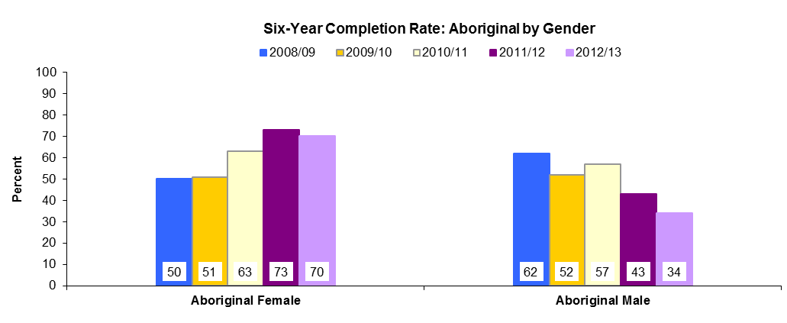

Grade Nine Transition

FSAs

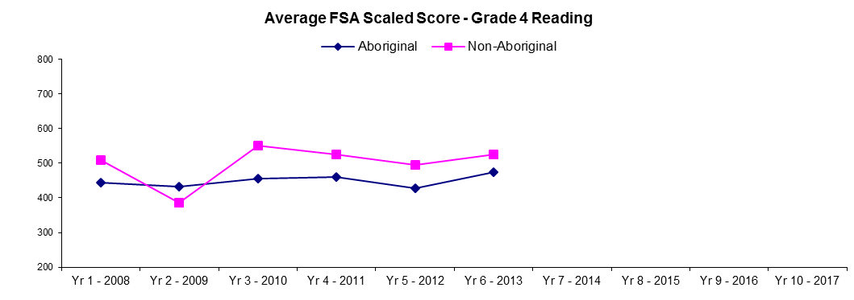

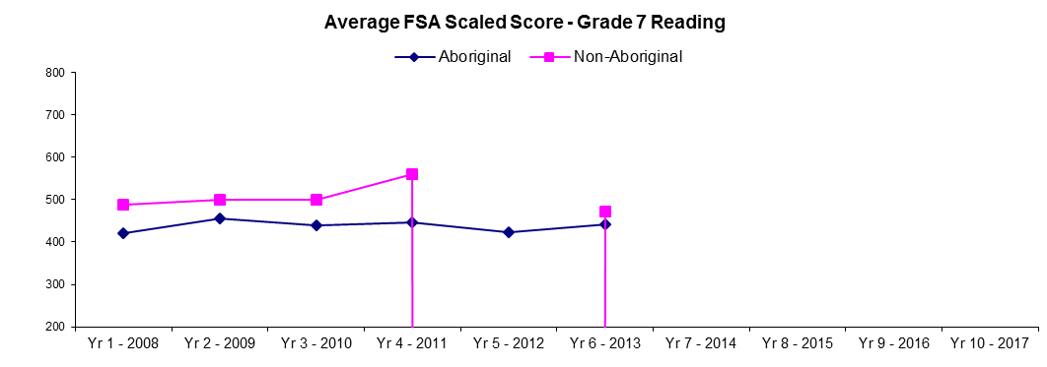

**2012-14 Sample Activities reflective of Goal Area** 2

*Improve grade transition rates and school completion rates, with enhanced academic performance in key meaningful high school subjects (English, math, science, social studies).*

|  |  |
| --- | --- |
| 2012-13 | 2013-14 |
| Math Meetings @ TAH & QCSS  UBC Math Consortium Math Book Presentation  English First Peoples 10 @QCSS  Port School: Math book presentation  District Day: Bentwood Box  UBC Learning Circles @SNES  UBC Storywork Challenge, Derek Siefert & Joanne Yovanovich submitted stories, Derek & students attended the Gala in Vancouver  Collaborate with Parks (Stephanie Fung) Curriculum  Science Fair @TAH  Project of Heart: GMD & QCSS  Red Cedar Gala @Port  NWCC meetings, Haida 101 curriculum, Marine school  UBC Intersection of Language, Learning and Culture in Early Childhood Education: Family, Community and school Contexts Math book presentation  Congress 2013 of the Humanities & Social Sciences @UVic Math Book Presentation | Alder Reading Club  UBC Math Meetings  Early Learning Forum  PALS  Food Programming  FNRW Training  Northern Native Public Legal Education Programme  Science Fair @TAH  Parks Collaboration  EFP 10 @QCSS  GMD Food Works Project and Book |

**Major Meetings related to Enhancement Agreement Goals**

HEC Meetings throughout the year

NW Zone Ab. Ed meetings

FNESC conference

