ALM Restart Safety Plan 2020/21
ALM has developed a Re-start Plan along with School District 50 guided by the Ministry of Education and the Provincial Health Officer. Keep in mind that our plan has to remain flexible and will be updated as new information comes to light. Here are the 5 different stages as laid out by the Province of British Columbia.
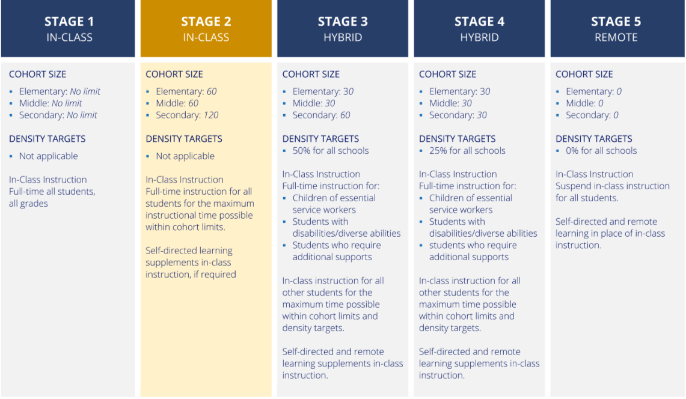
Supporting Documents
SD 50 SafeWork Instructions - https://sd50.bc.ca/wp-content/uploads/2020/08/Covid-Safe-Work-Instruction-Stage-2-Draft.pdf
BC Schools Re-start Plan - https://www2.gov.bc.ca/assets/gov/education/administration/kindergarten-to-grade-12/safe-caring-orderly/k-12-covid-19-health-safety-guidlines.pdf
Pandemic Response Plan - https://sd50.bc.ca/wp-content/uploads/2020/08/SD50-Pandemic-Response-Plan.pdf
Exposure Control Plan - https://sd50.bc.ca/wp-content/uploads/2020/08/SD50-COVID-19-Exposure-Control-Plan.pdf

Learning Groups
- ALM’s total school population is less than 30 so we can operate as one cohort or learning group. Even though this gives the appearance that we are operating as close to “normal” as we can, students and staff must minimize contact (no hugging, high fives, etc.). Students and staff do not have to maintain the 2 m rule or wear a mask around each other. If either staff or students choose to wear a mask and or face shield, please respect their personal preference.

- We only have a few staff members that travel between other schools, when they are at ALM they will be required to maintain a 2m distance. If a 2m distance cannot be maintained the visiting staff member will wear a mask/face shield.

Return of Students
- All students will be returning to school on Monday, September 14th
- Students and families are expected to perform the Daily Health Check before arriving at school.
- Students will enter from the main entrance doors and exit from the north end doors.
- All students will use the hand sanitizer before entering and re-entering the schools.
- Arrow and physical distancing decals will be place on hallway floors and throughout the school to control traffic and to minimize contact.
- Students will be spending more time outdoors so please send appropriate outdoor clothing
- We recognize that physical distancing will be a challenge in a K-7 setting. Students will be supported to minimize physical contact with one another. Staff will maintain a safe physical distance whenever possible.

Communication to Families
- Staff and parent/caregiver communication are primarily through email as well as our Facebook page. Brenda (Admin Assistant) and I will be sharing the Daily Health Checklist with parents and students through the emails provided. This will be the document to refer to as part of the student’s orientation.
- Parents can also check the school district website for latest updates.

Initial Schedule
September 8th – 11th Tuesday to Friday
Only staff are expected to be at school. This will be a staff orientation and planning week. Included in the week will be Health and Safety sessions, check-in’s with parents/guardians, as well as planning for our first week back with students.

September 14th – Monday
Early dismissal at 12 pm – whole school attends (orientation for students, i.e. hand washing, keeping physical distance, no sharing anything, movement rules, etc.).

September 15th – Tuesday
First full day of instruction moving forward.
Daily Health Check
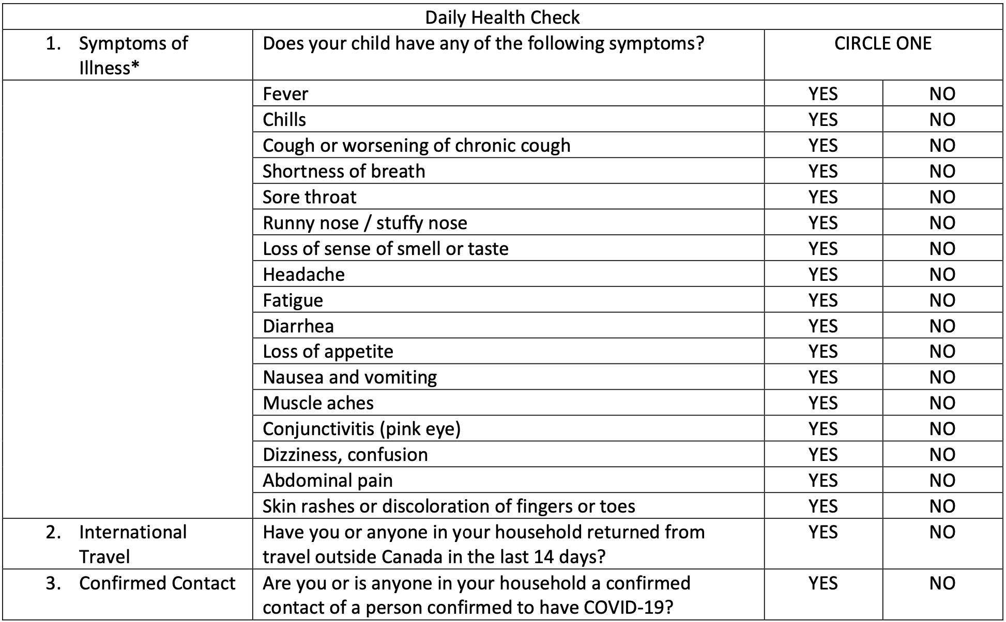
*Check BCCDC’s Symptoms of COVID-19 regularly to ensure the list is up to date.
If you answered “YES” to any of the questions and the symptoms are not related to a pre-existing condition (e.g. allergies) your child should NOT come to school.
If they are experiencing any symptoms of illness, contact a health-care provider for further assessment. This includes 8- 1-1, or a primary care provider like a physician or nurse practitioner.
If you answered “YES” to questions 2 or 3, use the COVID-19 Self-Assessment Tool to determine if you should be tested for COVID-19.
- A health check will need to be completed by families/students before coming to school everyday

School Premises
- Students will use cubby areas
- Students will use indoor shoes at school
- Staff will model appropriate physical distancing etiquette
- Playgrounds are open to registered students only. They will not be sanitized, and students will be expected to minimize contact. Hand washing will happen before students head out and return for recess and lunch.
- The gym will be open for school use only.
- The multi-purpose room will be used for an isolation room for students who become ill at school. Parents/Guardians will be asked to come and pick up their child as soon as possible.
- Washrooms will be limited to one student at a time.
Access to Agnes L Mathers Elementary School
- All visitors are required to make an appointment with the main office if they would like to talk with any staff.
- Entrance will be through the main front doors, where we ask that you sanitize your hands prior to entering the school and that you wear a mask and observe social distancing rules.
- Exit will be the North side entrance.
Cleaning and Hygiene
- Staff and students will be required to sanitize/wash their hands before entering and exiting the school.
- Students and staff will be encouraged to regularly wash their hands throughout the day. We will be setting aside time throughout the day to teach and give friendly reminders to staff and students alike about the importance of good hand hygiene.
- There will be hand sanitizer throughout the school as well and students will be expected to wash their hands in sinks before and after any snack or lunch times.
- Hand washing signs are posted above every sink and throughout the school to remind staff and students of frequent handwashing protocols.
- ALM will be cleaned and disinfected by our daytime custodian (all high-contact surfaces, traffic areas, and bathrooms). Our regular custodian will also be cleaning the entire school at the end of the day.
- Students should also wash their hands: When they sneeze or cough into their hands. When they handle common re: sources/equipment or supplies and after using the bathroom.

Food/Water

- We will be operating hot lunch under the new health and safety guidelines once a week starting on the 23rd of September. (washing or sanitizing hands before and after eating)
- Healthy snack will also be operating within the same guidelines (start date to be announced).
- Staff and students are not allowed to share food
- All water fountains are closed.
- All students are required to bring full water bottles to school each school day.
Field Trips
- Students will be reminded to physically distance during all field trips, walks or outdoor activities.
- Hand sanitizer will be available if handwashing with soap is unavailable.
- Sharing of snacks is not recommended, and gloves should be worn if passing our food our equipment.
- Equipment should be wiped down with cleaner or disinfectant wipe if needed.
- If travelling by car, students must go with a staff member or their own parent.
PPE (Personal Protective Equipment). i.e. masks/shields
The provincial COVID-19 document, B.C.'s Back to School Plan - Province of British Columbiawww2.gov.bc.ca › k-12 › covid-19-return-to-school states under PPE: Staff moving from cohort to cohort must wear a mask/shield. The first aid attendant is required to wear a mask when assisting a staff member or student. Staff and students will be supplied with masks.
Continuity of Supports: Students with Diverse Abilities/Disabilities Requiring Extra Support
- SRT will continue to communicate with parents of students with IEP’s. This may be in person, by phone, E-mail, and/or virtually.
- SRT will continue to provide individual or small group support as needed with appropriate physical distancing. More in-class support will be encouraged
- Specific plans may need to be made with students who require more one-to-one support with close proximity
- EA support will stay within Learning groups whenever possible
- If necessary and appropriate, some specialized instruction will occur virtually
- If a student is unable to attend in-person for health reasons, technology may be provided to families, if needed to meet learning outcomes and/or IEP goals and objectives
- Goals/objective may need to be revised to reflect the current situation i.e.: social goals
- If learning from home, students may have peer and teacher contact using technology and online resources where appropriate
- Counsellor will also connect with families as needed, information will be sent out with contact info. and resources for families
Note: If a medical professional determines that a student cannot attend school due to their health risks, the school district will work with the family to review alternative learning options for the student.
Staff or Student(sick)

If either a staff member or student is sick, they must stay at home. We will be adhering to the following guidelines:
  - Staff or students who have symptoms of COVID-19 OR travelled outside Canada in the last 14 days OR was identified as a close contact of a confirmed case or outbreak must stay home and self-isolate.
  - Staff and student must stay home or go home and follow the directions of their health care provider when sick with the common cold, influenza or COVID-19 symptoms.
  - Parents/caregivers must assess their child daily for symptoms of common cold, influenza, COVID-19, or other infectious respiratory disease before sending then to school. Please use the attached Daily Health Check before your child comes to school.
  - If students become symptomatic at school, they are to be led to the multi-purpose room maintaining appropriate physical distance. Staff is to call home and have parents come pick them up.
  - Symptomatic employees are to inform the onsite administrator and go home and self-monitor.
  - The 811-health line can be called for further information.
If there is a confirmed case of COVID-19 in your family, you DO need to self-isolate for 14 days.
Haa’wa

Will Bedard
Principal wbedard@sd50.bc.ca

